**1. Introduction**

This assignment will help you to consolidate the concepts learnt in the session.

**2. Problem Statement**

Given a list of numbers - List[Int] (1, 2, 3, 4, 5, 6, 7, 8, 9, 10)

- find the sum of all numbers

- find the total elements in the list

- calculate the average of the numbers in the list

- find the sum of all the even numbers in the list

- find the total number of elements in the list divisible by both 5 and 3

**3. Output**

Given a list of numbers - List[Int] (1, 2, 3, 4, 5, 6, 7, 8, 9, 10)



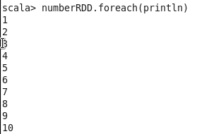



- find the sum of all numbers

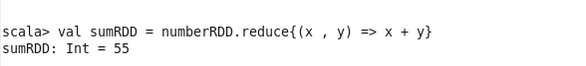

- find the total elements in the list



- calculate the average of the numbers in the list



- find the sum of all the even numbers in the list

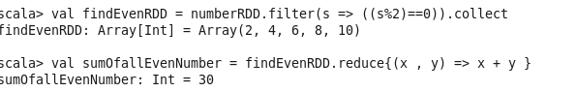

- find the total number of elements in the list divisible by both 5 and 3



